Feifan Tai(NUID 002138099)

The result of the experiment deviated considerably from my prediction.

My prediction:

Time(Reversed)>Time（Random）>Time(Partial Ordered)>Time(Ordered)

Outcome:

As I get more and more elements in the array, I find

Time(Partial Ordered)>Time(Reversed)>Time(Random)>Time(Ordered)

**My guess is that partial sorting of the array increases the entropy of the array. When there are enough elements in the array, the entropy of partial sorting will increase more than the entropy of reversed sorting, resulting in more time consuming partial sorting.**

**Conclusion:**

**When there are not enough elements in the array, the experimental results are in agreement with my prediction.**

**Time(Reversed)>Time（Random）>Time(Partial Ordered)>Time(Ordered)**

**But when the number of the elements in the array is huge enough, It would be the same as my experiment outcome.**

**Time(Partial Ordered)>Time(Reversed)>Time(Random)>Time(Ordered)**

Screenshot:

（Unit test outcome） BenchmarkTest

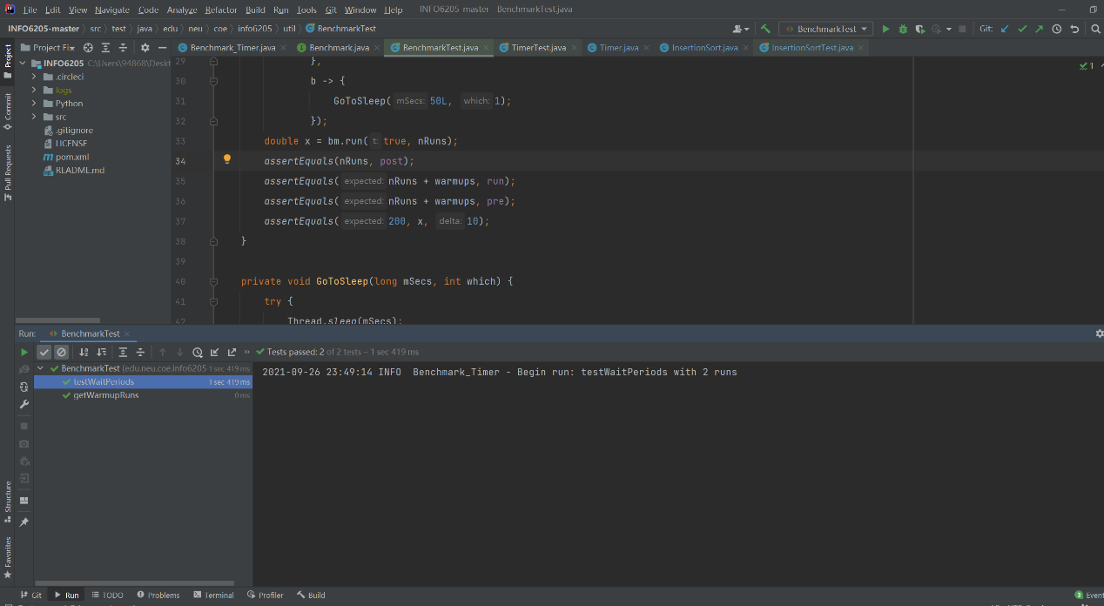

TimerTest

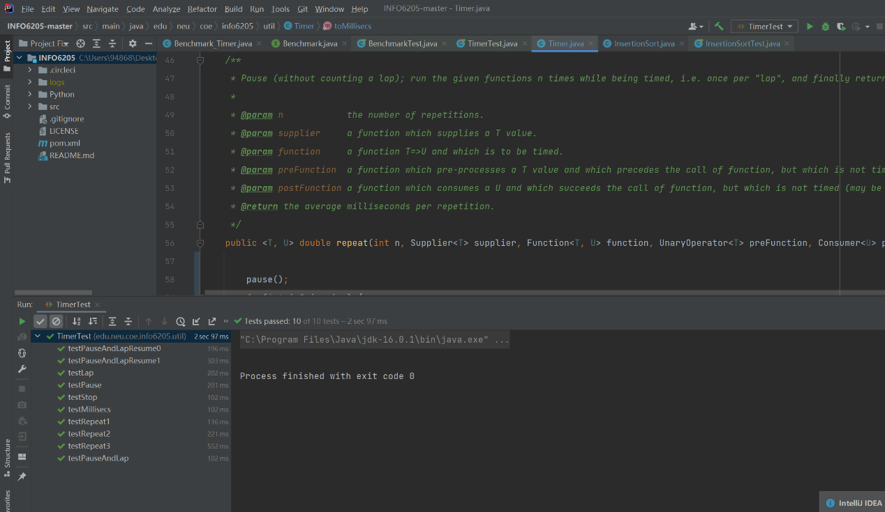

InsertionSortTest

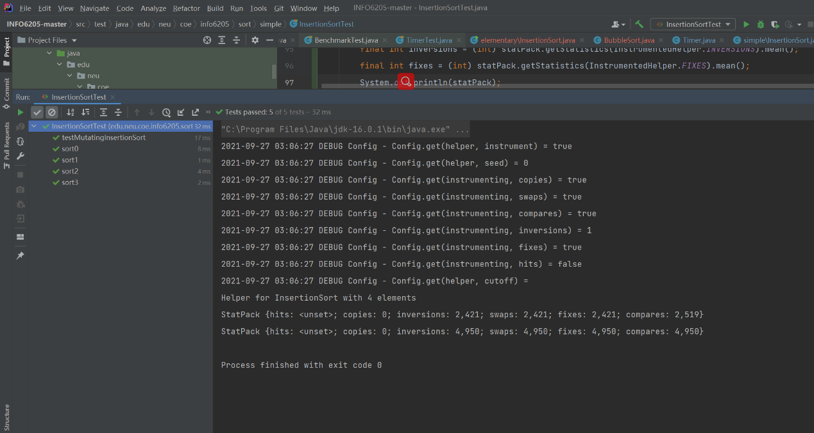

Experiment Output:

